- Open your own laptop or desktop (or use an online PC hardware simulator if you don't have access to a real system) and identify the GPU model installed. Write down the GPU's brand, model number, and whether it is integrated or dedicated.

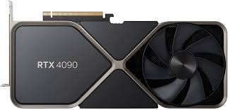

RTX 4090
- Brand: NVIDIA
- Model Number: 900-1G136-2530-000
- Type: Dedicated

- Take a clear photo or screenshot of the cooling system (fan, heatsink, or liquid cooling setup) inside your PC or from a PC hardware simulator. Label the main cooling components and briefly describe their function.

- actively dissipate the intense heat generated by the processor. By forcing cool air through a metal heatsink, it prevents the CPU from overheating, ensuring stable system performance and preventing permanent hardware damage.

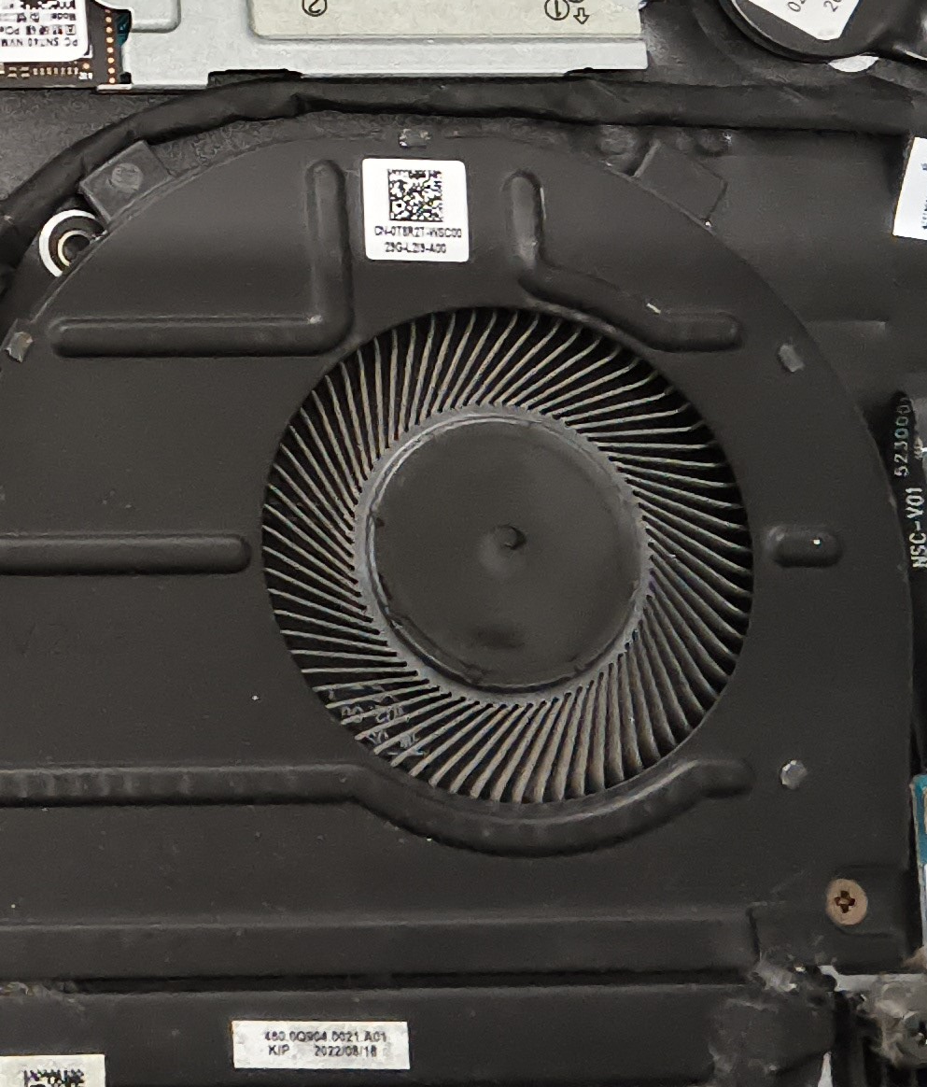

3. Create a comparison table listing at least 3 differences between air cooling and liquid cooling systems for GPUs, including factors like cost, efficiency, and maintenance.

Factor | air Cooling | Liquid Cooling
Cost | Generally cheaper, initial setup is less expensive | Usually more expensive due to components and installation
efficiency | Adequate for most gaming and standard tasks | More efficient at heat dissipation, suitable for overclocking and high-performance GPUs
maintenance | Low; periodic cleaning of fans and heatsinks | Higher; requires checking for leaks, coolant refilling, and system cleaning

4. Imagine you are building a gaming PC for streaming IPL matches and playing graphics-heavy games. Choose between air cooling and liquid cooling for your GPU, and justify your choice in 3-4 sentences based on your research.

- I would choose liquid cooling for my GPU maintaining high performance during long gaming and streaming sessions of graphics-intensive IPL matches. Liquid cooling systems are generally quieter and more efficient at managing heat, allowing my GPU to overclock safely and run smoothly without thermal throttling.

